Launcher
To start the test, I followed the tutorial on the photon. With it, I was able to connect to their servers and enter/ create rooms.
I started by creating a launcher scene where you can put your name and connect to the server.
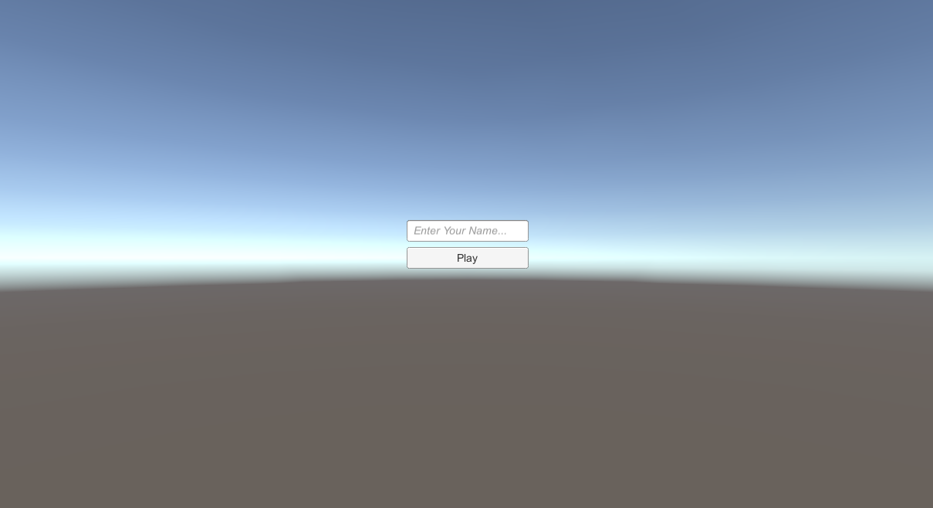
I then created a launcher script where I create the logic to connect to the servers.
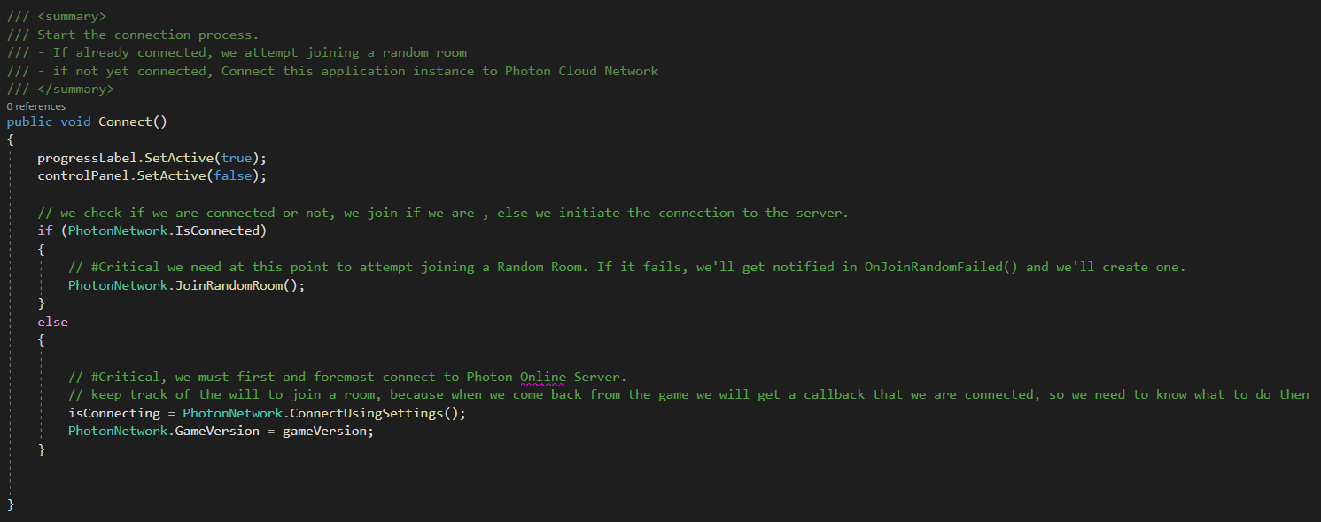
Every time the player tries to connect, it will detect if a game is already running online. 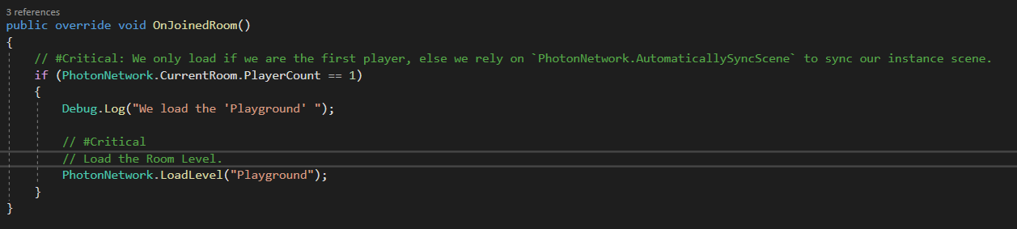
if no game is running, it will create a room a new room for the game.
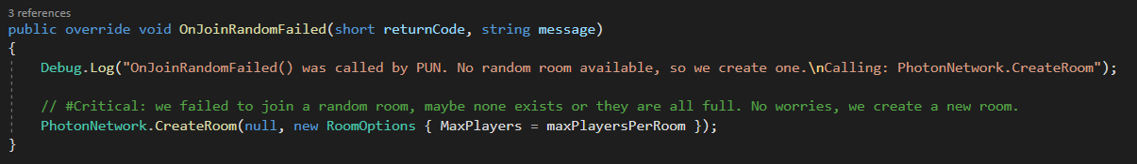

Game Manager
Then I used the Third Person Scene of StartAssets to create the playable environment.
There I create a Game Manager that takes care of connecting and creating all the players' characters.
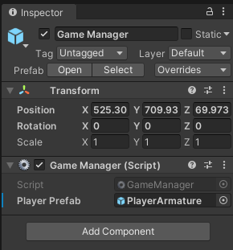
There are some methods in this class but the one I want to point out is the Start method, where the manager creates the player character from a prefab located on the resources folder.
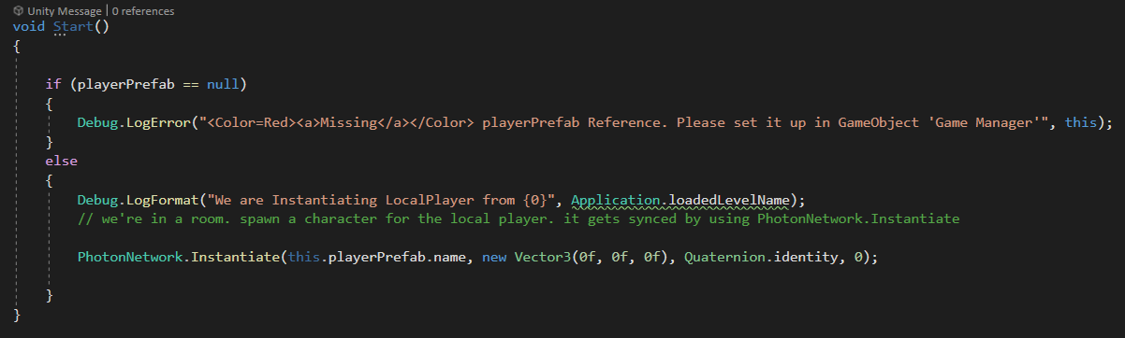
There are also methods on Player joined/left the room, but I didn’t use them, just in case it's needed and for log purposes.
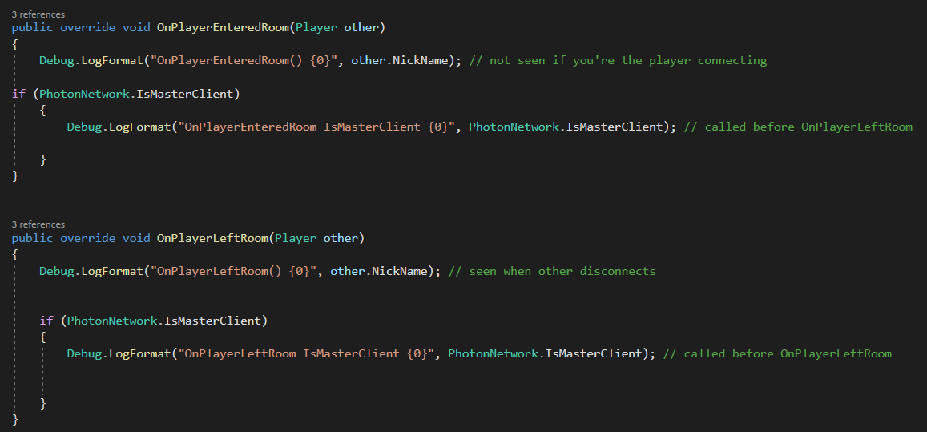

Player Character
This is the part where I spend more time since here everything is mostly custom.
For the player, I started by adding some photon components.
Photon View
Connects to the rest of the photon components and communicates with the server.
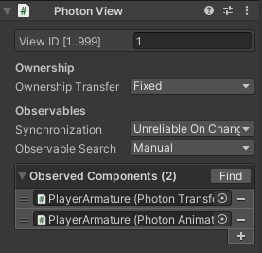
Photon Transform View
Tracks the transform of the object (position, rotation, …)
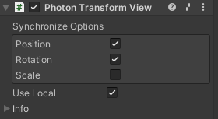
Photon animator view
Tracks all the animation variables and synchronises them with the other players (it made it really easy, you just add them to the object, and it detects and animator component automatically)
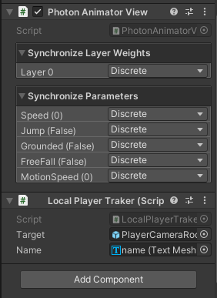
Basically, these three components made it so all the characters are synchronised.
The only problem I had was with the animation because the character movement code was overwriting it.
I just had to add a check on the character update to see if the character was owned by the local player and then progress as normal.
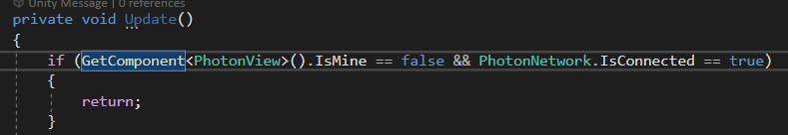

Camera
To make the camera work, I just add to create a new script for the player character where it detects if I’m the owner of the character and then assig the tracker to the CinemachineVirtualCamera.
This was one of the parts where I had more problems mostly because I didn’t know how to detect if I’m the owner of the character.

Nick Name
To identify the characters, put the owners’ names on top of them.
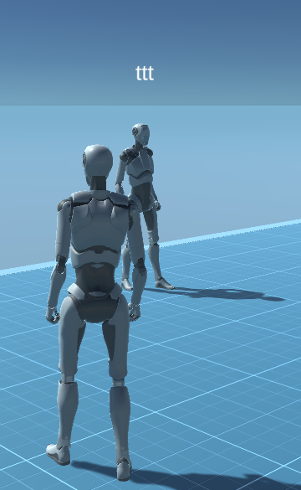
To achieve this, I started by adding a canvas, in real word space, to the players, with a TPM UI text.

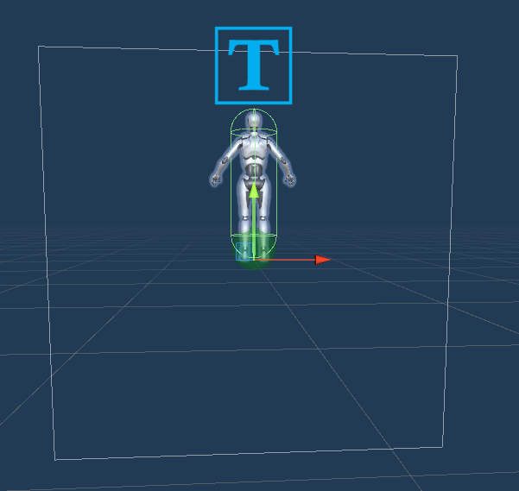
Then on the Local player tracker script, I modified the text with the nicknames stored on the photo view component.
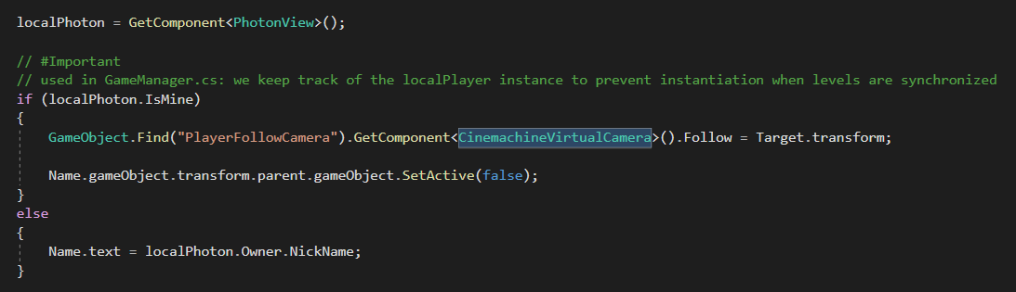
And made it so the canvas always faces the camera.
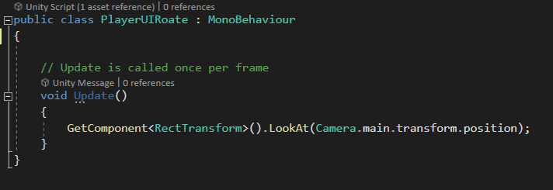

Extras

Box Pick up
This was the part where I had more difficulties.
Mostly because I didn’t know how to send custom information at first.
I started by creating a prefab of a box that can be targetable. To identify that I used a tag, and used a ray cast from the camera.
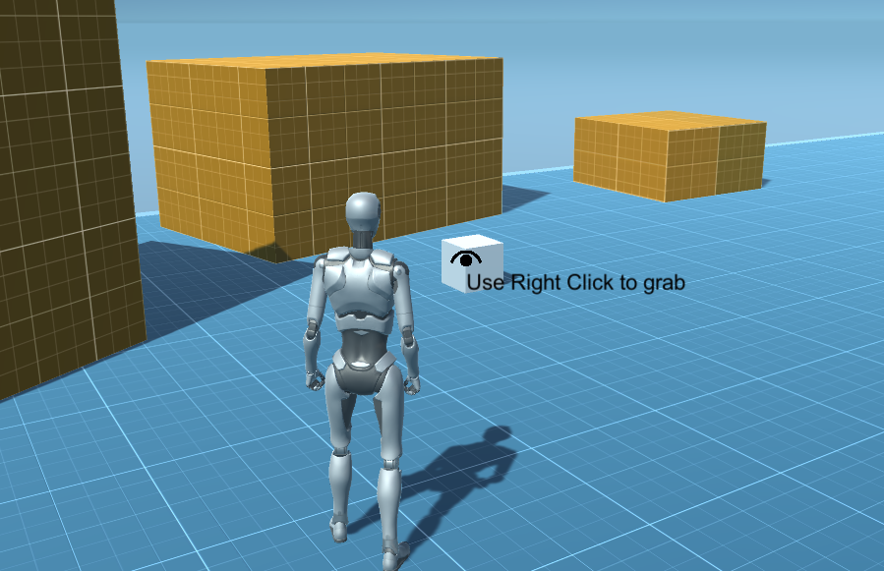
Then I just use the right click of the mouse to pick it up.
For this, to work I used 2 scripts “GrabItems” and “CubesLogic”.
Grab Items takes care of targeting the cubes and picking them up.
I use states to optimise as much as possible.
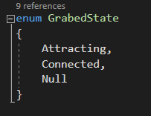
Null state
The Null state just uses the ray cast and detects the mouse click.
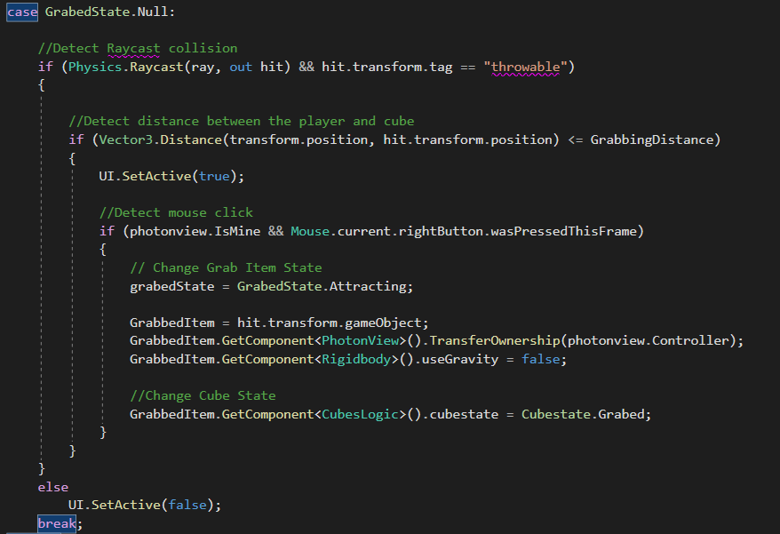
Attracting State
I wanted to create the effect of the cube coming to you instead of just teleporting it, so I created the attracting state where I used Vector3 lerp to slowly drag it to you.
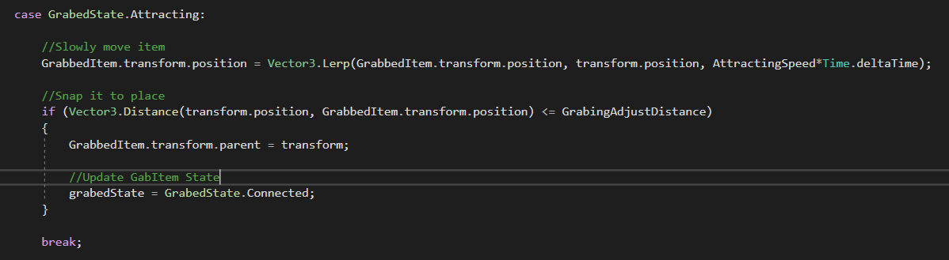
Connect State
Does basically the same thing as the previous one but add the possibility to right-click to release.
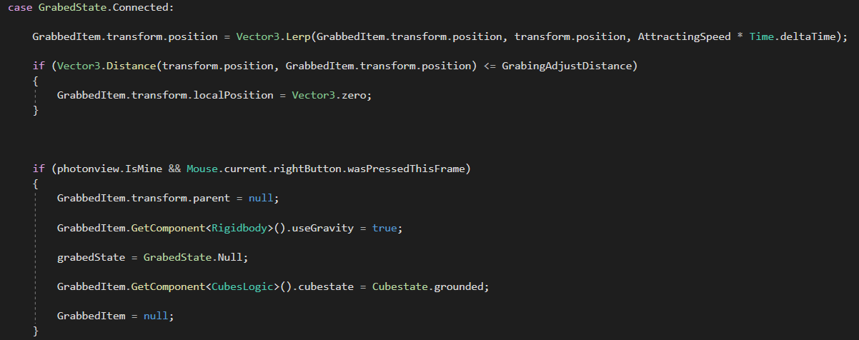
Now the difficult part syncing, at first, I thought it would be easy, I was thinking of using the photon components to track the position and update it.
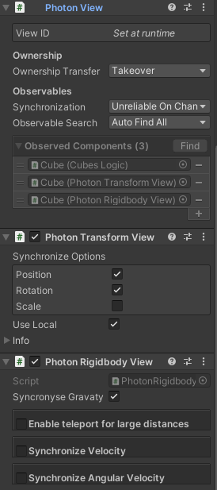
But I figure out quickly that it wasn’t enough since I was applying logic on the cubes that weren’t being tracked, like the tags, or the gravity on the rigid body.
After learning how sending and receiving info worked, I tried to use it on the GrabItem script, by updating the States (good organisation of my past self ;D) and updating the game object target.
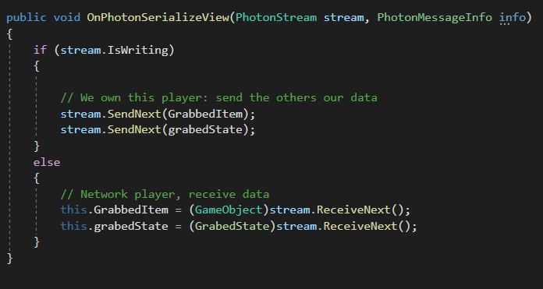
But unfortunately, you can’t pass gameOjects.
So, I went to the cubes instead, first to solve the gravity problem, I changed the photon script by adding a gravity track.
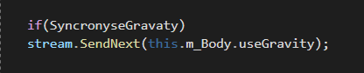

Then I used the Cube Logic script to update the tags and basically make them untreatable to other players while grabbed.
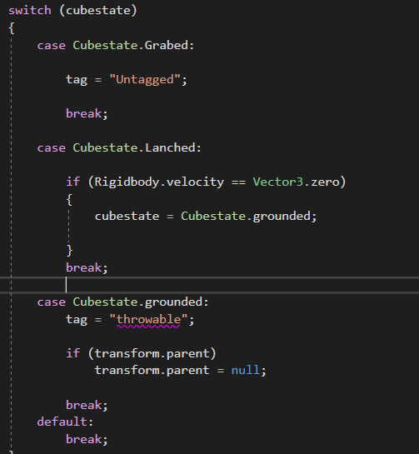
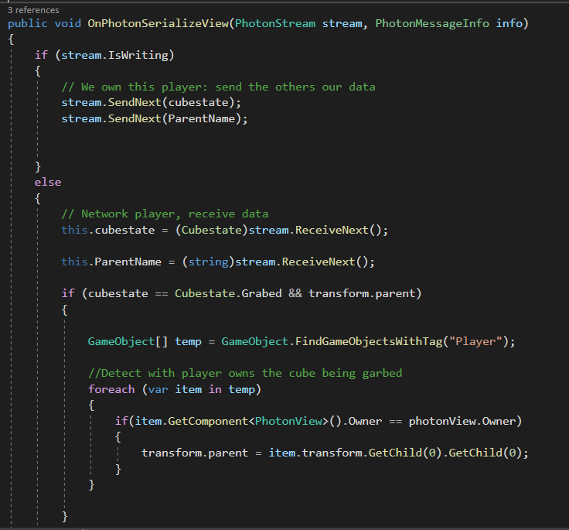
Since I was having some problems with the cube not being completely fixed on the eyes of other players, I tried to snap them to the pivot by making it parent but there are some issues still.

Health
For this, I just used a slider as a health indicator on the player.
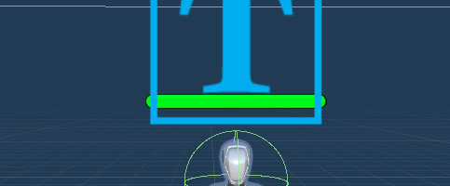
And for code, I used the photon method to send information.
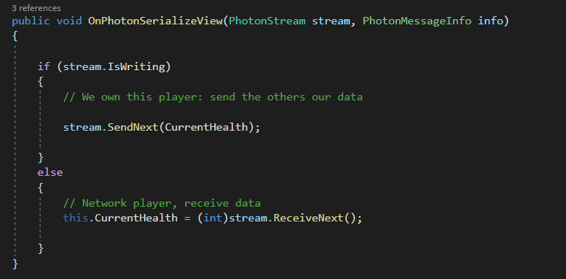
You can throw the cubes to other players to damage them
